CHECK OUT REPORT OF CONDITION AT

47C COURTFIELD GARDENS

LONDON

SW5 0NA

5TH SEPTEMBER 2019/ 7TH SEPTEMBER 2020

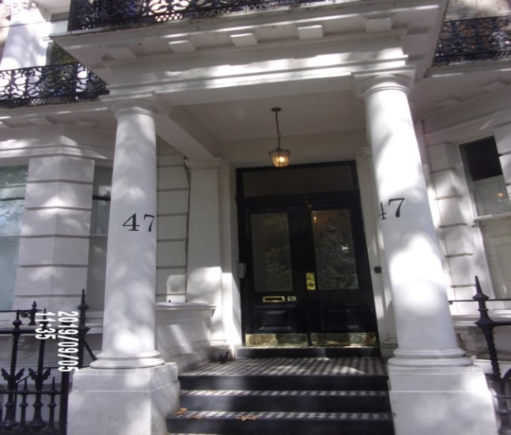

|  |  |
| --- | --- |
| **CLIENT:** | London Central Portfolio |
| **INSTRUCTED BY:** | Olivia Highwood |
| **JOB NO:** | 3306 |
| **REF:** | MBPS-002 / MBPS-002 |
| **INSPECTED BY:** | Janice Richardson |
| **PROPERTY SIZE:** | 1 Reception / Bedrooms / 2 Bathrooms - Furnished Flat |

'WINDY RIDGE' [99 COWLEY HILL, BOREHAMWOOD, HERTS, WD6 5NA](https://maps.google.com/?q=99+COWLEY+HILL,+BOREHAMWOOD,+HERTS,+WD6+5NA&entry=gmail&source=g),TEL: 020 8 386 0950 - MOBILE: 077 67 647 647  
EMAIL: [info@inventorys.net](mailto:info@inventorys.net)[www.inventorys.net](http://www.inventorys.net/)  
Registered No: 4263261 VAT No: 822 9322 12

Safety Disclaimer

This inventory report is prepared as an ‘as seen snapshot’ of the property and its contents at the time of the designated inspection and is compiled as a fair and accurate record for the properties internal condition and contents. This does not form any part of a valuation or structural report.

This inventory is compiled on the basis that all items listed are in good order and clean. Any defects or soiling are noted where appropriate. Where inspections are carried out and the tenants’ belongings are in situ, it can be difficult for clerks to differentiate to that belonging to the landlord or tenant. Should the report contain inaccuracies the clerk (Independent Inventories (UK) Ltd) will not be held responsible.

The clerk preparing the inventory is not an expert in electrical appliances, antiques, furniture style, fabrics, flooring, etc. All descriptions within this report are for identification purposes only in order that each item can be compared to its condition at the commencement of the tenancy.

Lofts and Cellars are not included unless they are converted and safely accessible. Contents will therefore not be noted or checked at check-in or checkout.

Plants and shrubs will not be itemised.

Belongings left by the landlord/agent in a locked room or outbuilding will not be inventoried and are the sole responsibility of the Landlord/agent. Items in garages/sheds such as garden equipment and tools will be inventoried, however tins of paint will not be itemised.

We do not undertake to move heavy items of furniture or access lofts, high-level cupboards, or any other inaccessible places. Contents which have been left in the above-mentioned areas, which have not been inventoried, are the sole responsibility on the landlord. We also do not undertake to open windows, but will confirm whether keys have been seen or not.

Any electrical appliances tested will be for power only and only where practicable. The clerks are not qualified electricians and will only confirm the visual condition of the electrical socket, wiring and or fitting as seen. Boilers, Heating Systems, Gas Fires, Water Supply and Radiators are not tested, and Independent Inventories (UK) Ltd will not take any responsibility for units left either on or off even if on automatic timers. Where smoke alarms and CO Detectors are tested this is for power only and should not be taken to mean that the alarms are in full working order. We only state their presence and cannot state the functioning of this equipment. No responsibility is taken for any damage or malfunction occurring during the testing of such alarms.

The relevant utility companies must check all meter readings, as we cannot be held responsible for any discrepancies. We are not held liable should meters not be located or inaccessible to read. For Health and Safety reasons we do not expect our clerks to access high level areas which involve using ladders/chairs.

The Fire & safety Regulations regarding furnishings, gas, electrical & similar services are ultimately the responsibility of the instructing principle. Where the inventory notes FFR label seen, this should not be interpreted to mean that the item complies with the furniture & furnishings (fire) (safety) (Amendments) 1993. It is a record that the item had a label as described or similar to that detailed in the Guide to the regulations as published by the Department of Trade & Industry, January 1997, (or subsequent edition), attached at the time the inventory was complied.

Blinds in the premises are visually checked. We are unable to verify that the blinds comply with child safety requirements of BS EN 131202009 + A1:2014 placed on the manufacturer, supplier and professional installation of internal window blinds

It is the responsibility of the landlord/managing agent/tenant to agree between themselves the accuracy of the report, and Independent Inventories (UK) Ltd should be notified within 7 days of receipt of the report of any discrepancies within the report.

GENERAL GUIDANCE NOTES

Independent Inventories do not have site of tenancy agreements or other agreements made between the tenant, landlord and management company. As these are guidance notes only it is always advisable that the tenancy agreement is cross referenced. This report will indicate whether in our opinion the tenant is liable for the deterioration or whether it is considered fair wear & tear. Independent Inventories may suggest maintenance, cleaning or tenant’s liability at checkout, but the final responsibility of these suggestions will fall with the landlord or managing agent in respect of the original tenancy agreement. We do not suggest costs of any items, these should be sourced from the relevant contractors by the landlord or managing agent.

CLEANING

We recommend that a professional cleaning company is employed at the end of the tenancy, unless alternative arrangements have been agreed with the Landlord/Managing Agent. Receipts from professional cleaning and carpet cleaning companies must be present to the clerk at the checkout inspection.

If the standard of cleaning is not satisfactory most Landlords/Managing Agents will contract a cleaner and their charges will be charged to the tenant unless otherwise stated in the tenancy agreement.

DECORATION

It is accepted that during the course of the day to day living scuffs will appear on walls and woodwork. However should the marks be found to be excessive charges will be made to you the tenant, unless otherwise stated in the tenancy agreement.

LIGHTING

If the lights are working at check-in then it is normal, if lights are not working at checkout, for these to be the responsibility of the tenant to replace bulbs or to be charged accordingly, unless otherwise stated in the tenancy agreement.

GARDENS/PATIO

If the standard of the garden/patio is found to be untidy compared to the start of the tenancy the Landlord/Managing Agent are entitled to employ a contract gardener and the charge will be made to you the tenant, unless otherwise stated in the tenancy agreement.

MAINTENANCE ISSUES

We recommended should any maintenance issues arise you contact the Landlord/Managing Agent immediately so they can deal with the matter. Should we recommend items require maintenance once a property has been checked out, this is purely stating that an item will require fixing/attention, we are not advising as to whose responsibility this and your tenancy agreement will need to be checked.

CHANGES TO PROPERTY

We recommend that if you wish to make any changes to the décor or remove any of the Landlords belongings you contact the Landlord/Managing Agent for permission and have this confirmed in writing to ensure there are no discrepancies at the end of the tenancy.

TENANTS INFORMATION FOR CHECKING OUT OF PROPERTY

It is important at the checkout that:

1. All cleaning should be completed prior to the checkout appointment as per the tenancy agreement.
2. All personal items must be removed prior to the check out.
3. All items should be in the same location as per the inventory, any stored items should be unpacked and also returned to the same location.
4. If the Inventory clerk has to search for items or you still have belongings in the property to be removed this will result in additional charges being made to the tenant.
5. All beds should be left unmade with the linen folded. Bedding & towels should be cleaned & ironed where relevant.
6. All food items should be removed, freezers defrosted & doors left open & electricity turned off.
7. All light bulbs etc. should all be in working order as at check in.

The property should be left in a clean and tidy condition especially carpets, curtains, windows, upholstery appliances etc. We would suggest that you refer to your tenancy agreement in this matter.

If you are not ready to leave it may not be possible to carry out the checkout. In this case a return visit will be necessary resulting in a cancellation charge.

All keys to the property must be handed over at the time of checking out to the Inventory clerk or alternatively to the agents prior to the check out taking place.

The Inventory Clerk acts as an independent and reasonable body and will avoid unnecessary criticism or derogatory comments when compiling or checking the Inventory.

At the termination of the tenancy the inventory will be checked and any obvious or significant discrepancies will be reported to the Managing Agent/Instructing Principal. This report will indicate whether in our opinion the tenant is liable for the deterioration or whether it is considered fair wear & tear. Normal fair wear and tear will be assessed on the lengthy of the tenancy and type occupancy.

INDEX

PAGE

|  |  |
| --- | --- |
| UTILITY READINGS | 1-2 |
|  |  |
| KEYS | 3 |
|  |  |
| GENERAL SUMMARY | 4 |
|  |  |
| INSTRUCTION MANUALS | 5 |
|  |  |
| ENTRANCE HALLWAY | 6-10 |
|  |  |
| BATHROOM | 11-17 |
|  |  |
| BEDROOM 1 | 18-23 |
|  |  |
| KITCHEN / RECEPTION | 24-38 |
|  |  |
| BEDROOM 2 | 39-44 |
|  |  |
| BATHROOM 2 | 45-49 |
|  |  |
| DECLARATION AT CHECK IN | 50 |
|  |  |
| ADDITIONAL AMENDMENTS | 51 |
|  |  |
| CHECK IN SIGNED SCHEDULE OF CONDITION | 52-60 |

**UTILITY READINGS / KEY LIST& INSTRUCTION MANUALS**

|  |  |  |
| --- | --- | --- |
| **ELECTRIC** | **GAS** | **WATER** |
| METER NUMBER:  S68A03447 | METER NUMBER:  344253S | METER NUMBER:  Not located |
| READING:  32459 | READING:  8784 | READING:  Not located |
| LOCATION:  Communal hallway cupboard | LOCATION:  Basement vault | LOCATION:  Not located |

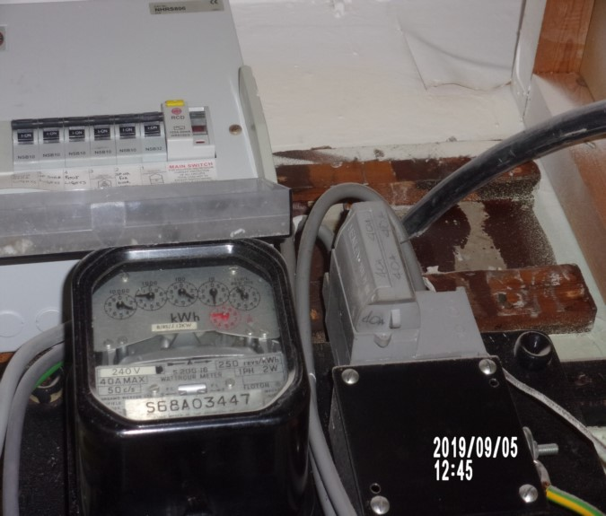 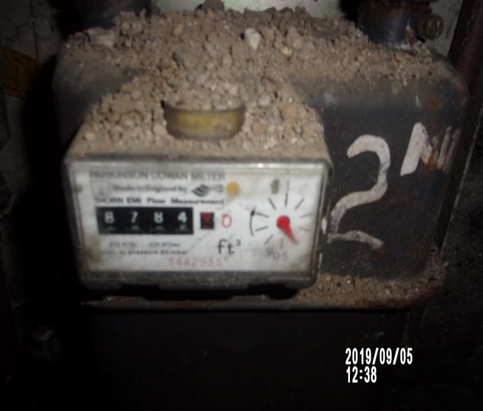

|  |  |  |
| --- | --- | --- |
| **ELECTRIC** | **GAS** | **WATER** |
| METER NUMBER:  1) S2BS 100 F00A 14425  2) 19L3830151 | METER NUMBER:  344253S | METER NUMBER:  Unknown |
| READING:  1) 61580  2) Credit mode balance 1324 | READING:  8925 | READING:  Not located |
| LOCATION:  Communal hallway cupboard | LOCATION:  Basement vault | LOCATION:  Not located |

|  |
| --- |
| **LOCATION OF:** |

|  |  |  |
| --- | --- | --- |
| **STOP COCK** | Not located | |
| **FUSE BOARD** | Hallway cupboard | |
| **ALARM PANEL**  **This has not been tested** | N/a | MAKE: |

|  |
| --- |
| **FIRE SAFETY** |

|  |  |
| --- | --- |
| **SMOKE ALARM 1** | Power light on  Not visible  Tested with Canned smoke and working order  Location: Hallway |
| **SMOKE ALARM 2** | Power light on  Not visible  Tested with Canned smoke and working order  Location: Kitchen / Reception |
| **CARBON MONOXIDE ALARM** | Tested and working order |

|  |  |  |
| --- | --- | --- |
| **KEYS AT CHECKIN** | **KEYS AT CHECKOUT** | |
| **KEY TYPE / SERIAL NUMBER / QTY** | **KEY TYPE / SERIAL NUMBER / QTY** |
| Management keys used (1 x Bramah and 1 x Yale) | 2 x Bramah 65d10007 |
|  | 2 x Brass Yale |
|  |  |
| **KEYS RECEIVED BY: Agent (J. Moran, Winkworth)**  \\Pc-1\mbps\II\8TH SEPT\FLAT C, 47 COURTFIELD GDNS - IN\52 photos 47c courtfield\New folder\52 keys (Copy).JPG | **KEYS RETURNED TO: Agent ()** | |

|  |
| --- |
| **GENERAL SUMMARY** |

|  |  |  |
| --- | --- | --- |
| **ITEM** | **CHECKIN NOTES** | **CHECKOUT NOTES** |

|  |  |  |  |
| --- | --- | --- | --- |
| **GENERAL CONDITION** | | Professionally cleaned for start of tenancy | No receipts seen for professional cleaning  Very good clean carried out  Tenants items left in property |
| **ODOUR** | | N/A | N/A |
| **DECORATIVE ORDER / WOODWORK** | | Good order  Defects as noted  Woodwork scuffed/ chipped | Defects as noted  Woodwork scuffed/ chipped |
| **FLOORING** | | Defects as noted  Vacuumed for the start of tenancy | Defects as noted  Vacuumed for the end of tenancy |
| **CURTAINS / BLINDS** | | Defects as noted  Good order | Defects as noted |
| **BLIND REGULATIONS** | | Chain break connector in place  Chain tidy in place |  |
| **UPHOLSTERY** | | Vacuumed in situ for the start of tenancy  Defects as noted | Vacuumed in situ for the end of tenancy  Defects as noted |
| **FFR LABELS** | Sofa: FFR labels not seen  Bedroom 1: FFR labels seen  bedroom 2: FFR labels seen | |  |
| **LINEN** | Freshly laundered | | In use  Freshly laundered |
| **LIGHTS** | All working order | | Bulbs not working |
| **KITCHEN / APPLIANCES** | All appliances power tested  Fridge/ freezer left shut power on  Final wipe required | | All appliances power tested  Fridge/ freezer left shut power on |
| **BATHROOMS/**  **WC** | Water outlets tested and working | | Water outlets tested and working  Mildew to areas as noted |
| **WINDOWS** | Fitments complete  Clean to interior | | Clean to interior |
| **GARDEN /**  **TERRACE** | N/A | | N/A |
| **TELEPHONE** |  | | Handset provided |

|  |  |
| --- | --- |
| **MANUALS SUPPLIED AT**  **CHECKIN** | **MANUALS RETURNED AT**  **CHECKOUT** |
| **APPLIANCE / MAKE** | **APPLIANCE/MAKE** |
| None provided | None |

 *N.B – Heavy items will not be moved or inspected behind/under, for health& safety reasons. We will not be held liable should any damages/stains/marks be found during the tenancy in these areas. Should the occupant find any of the above they should, inform the landlord/agent immediately and if/where possible take photographic evidence and pass to the relevant parties.

 This camera symbol throughout the Inventory check in/out indicates where a photo has been taken. Photos can be found at the back of each room in the report with the relevant headings

# ENTRANCE HALL

|  |  |  |  |  |
| --- | --- | --- | --- | --- |
| Entrance Door | Wood painted white door  White painted wooden Frame  1 x stainless steel knob  3 x stainless steel locks | 1. Painted over crack to bottom left hand side panel  2. Discoloured to edges  3. Few scattered light rubs and marks  4. Chips low level  5. Low level scuffs |  |  |
| Interior | Wood painted white door  White painted wooden frame work  Brushed steel handle  3 x stainless steel swivel locks  1 x stainless steel knob | 1. Very light marks |  |  |
| Ceiling | Painted white with a section of white painted cornice | Good order  Some light grey shading seen  Recessed spotlights upon entrance chipping seen |  |  |
| Lighting | 4 x ceiling mounted spots with white surrounds | 1. ~~All working order~~  ~~All tested and working~~  1 x not working |  |  |

# ENTRANCE HALL

|  |  |  |  |
| --- | --- | --- | --- |
| **Walls** | Painted white | Light scuffing seen to the walls at mid to low level  Finger soil marks seen around the light switch  Odd rub marks seen |  |
|  | Back wall: |  |  |
|  | Left hand side wall:  3 x brushed steel single light switches  1 x brushed steel single fuse switch | Several light scuffs |  |
|  | Facing wall:  Mirror |  |  |
|  | Right hand side wall  1 x brushed steel single light switch  1 x brushed steel fuse switch  1 x brushed steel single telephone point  1 x brushed steel double socket | Minor angle nicks  Odd scuff above radiator at mid level |  |
| **Woodwork** | Wood painted white | Chipping seen to the corner edges at an angle  Light scuff marks seen in places |  |

# ENTRANCE HALL

|  |  |  |  |
| --- | --- | --- | --- |
| **Flooring** | White wood laminate flooring | 1. 2 x Chips forward of Reception  Light scratches seen to the top surface  Vacuumed for the ~~start~~ end of tenancy |  |
| **Heating** | 1 x white metal single panelled radiator with grille to top | 1. Valves complete  Appears to be intact and in good order |  |
| **Entry phone** | 1 x white and grey plastic video entry phone | 1. Not tested ~~and working~~ |  |
| **Mirror** | 1 x wall mounted unframed mirror | Clean to the top surface |  |
| **Storage cupboard** | High level single door storage cupboard with white painted wooden door  Interior:  Off-white plastic fuse box with cover  2 x heating timers  1 x white plastic fuse switch  1 x white plastic Worcester heating control | 1. Cover conflicts with base of cupboard  Dust build-up seen to interior |  |

# ENTRANCE HALL

|  |  |  |  |
| --- | --- | --- | --- |
| **Smoke alarm** | 1 x white plastic ceiling mounted | 1. ~~Not~~ Tested and working  2. Green light seen  ~~Too high for canister to reach not tested agent advised~~ |  |
| **Control panel** | Worcester control panel |  |  |
| **Additional** | Clothes rail, shoe rack and folding chair |  |  |

Flat Door Hallway

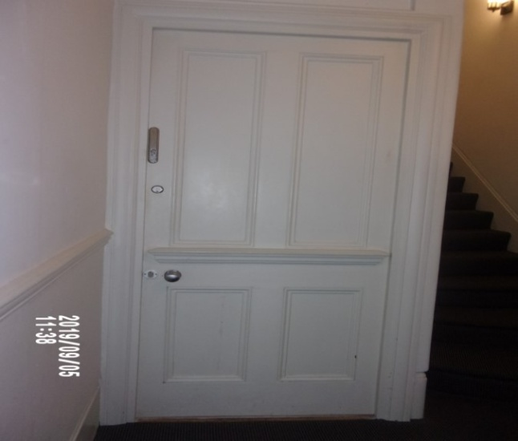 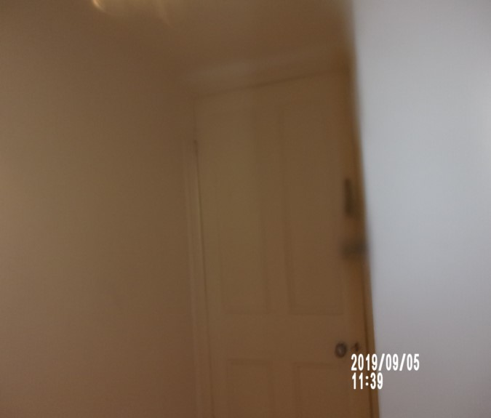

Hallway Chip to ceiling

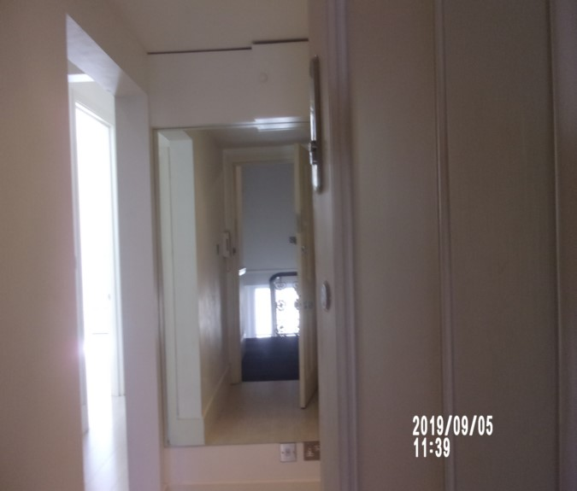 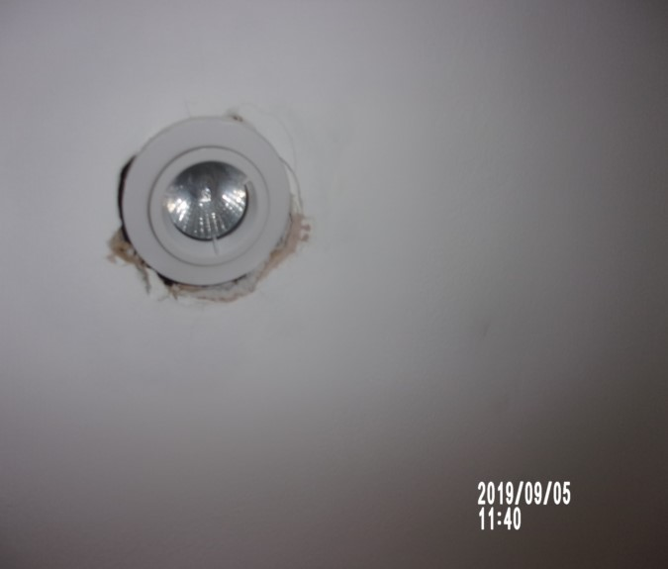

Hallway Dent to wall

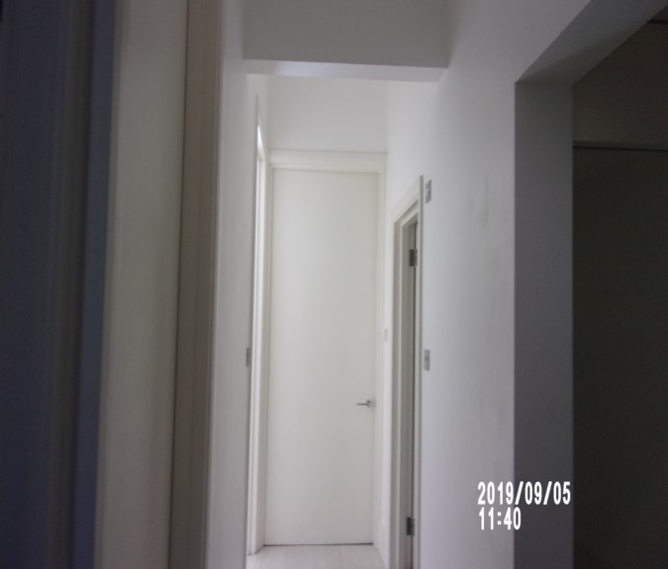 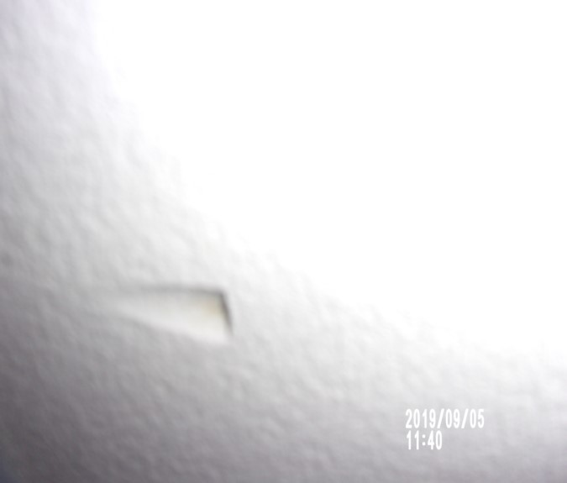

**BATHROOM**

|  |  |  |  |  |
| --- | --- | --- | --- | --- |
| **Door** | Wood painted white door  White painted wooden frame work  Stainless steel handle and lock either side | Exterior frame bottom right hand side some water damage seen  Flaking seen to the paint  Exterior door 1 or 2 x light rub marks seen at mid-level  Patchy paintwork seen around the edges of the frame |  |  |
| **Ceiling** | Painted white  Access hatch cut to far end | Old defects underneath |  |  |
| **Walls** | Part painted white  Part small multi-tone blue tiles | Scattered discolouration seen to grout in shower cubicle at mid to low level  Some light scuff marks seen at mid to low level in places  Rear facing wall some damage seen to the paintwork and tiles |  |
|  | Left hand side wall:  1 x white plastic shaving socket | 1 x dent from handle |  |

**BATHROOM**

|  |  |  |  |
| --- | --- | --- | --- |
| **Walls contd..,** | Facing wall:  1 x access hatch for stop cock with white painted wooden knob | Right hand side wall stress crack near window upper level to mid level |  |
| **Woodwork** | Light grey tiling | Odd chip to top right hand side |  |
| **Flooring** | Square light grey ceramic tiling | Discolouration seen to grout  Heavy discolouration forward of shower cubicle area  Vacuumed for the ~~start~~ end of tenancy |  |
| **Lighting** | 4 x ceiling mounted spots with white surrounds | ~~2 x lights not currently showing power~~ |  |
| **Heating** | 1 x stainless steel ladder style radiator | Clean to top surface |  |
| **Window** | Grey metal framed strip glazing single glazed window | 1. Paint cracking to the sill  Paint chipping and flaking aroundwindow area, quite heavy upper level  Clean to interior  Lightly soiled to exterior |  |

**BATHROOM**

|  |  |  |  |
| --- | --- | --- | --- |
| **Blind** | White metal venetian blind with Perspext wisting mechanism  Cord pulley mechanism with Perspex acorn | Working order / clean  1 or 2 x bent slats |  |
| **Basin** | White corian basin  Stainless steel mixer tap  White wood laminate single drawer mounted beneath | 1. Plug control conflicts with mirror behind – unable to close  2. Tap in working order  3. Tested and working / clean |  |
| **WC** | White pedestal WC with concealed cistern  White plastic slow close seat and lid  Stainless steel flush | 1. Tested and working  2. Clean |  |

**BATHROOM**

|  |  |  |  |
| --- | --- | --- | --- |
| **Shower** | White plastic tray  Stainless steel waste cover  Glass and stainless steel side panel to the sliding door  Stainless steel pull to either side of the door  Stainless steel shower control plaque to interior  Wall mounted stainless steel shower head | 1. Clean  2. Not tested |  |
| **Extractor fan** | White plastic ceiling mounted | ~~Not~~ Tested and working |  |
| **Storage cupboard 1** | 1 x single door storage cupboard to low level  White painted wooden door and frame work  Interior:  1 x shelf |  |  |

**BATHROOM**

|  |  |  |  |
| --- | --- | --- | --- |
| **Storage cupboard 2** | 1 x single door storage cupboard to high level  White painted wooden door and frame work  1 x white painted pull to exterior  Interior:  1 x white plastic fuse switch  1 x Worcester boiler | 1. Cover not attached to boiler  2. Well in use to interior walls  Power light seen |  |
| **Mirror** | Wall mounted unframed mirror |  |  |
| **Toilet roll holder** | 1 x stainless steel wall mounted | Intact |  |
| **Toilet brush and holder** | 1 x white plastic | In use |  |
| **Miscellaneous items** | Small grey plastic pedal bin  White opaque glass vase with faux flowers | Paint spots to lid |  |

Bathroom Bathroom

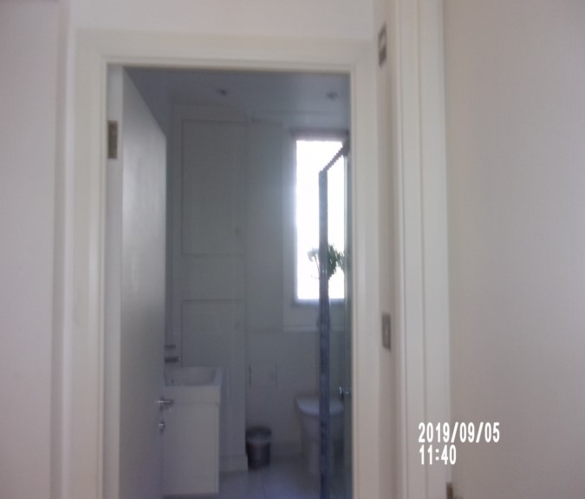 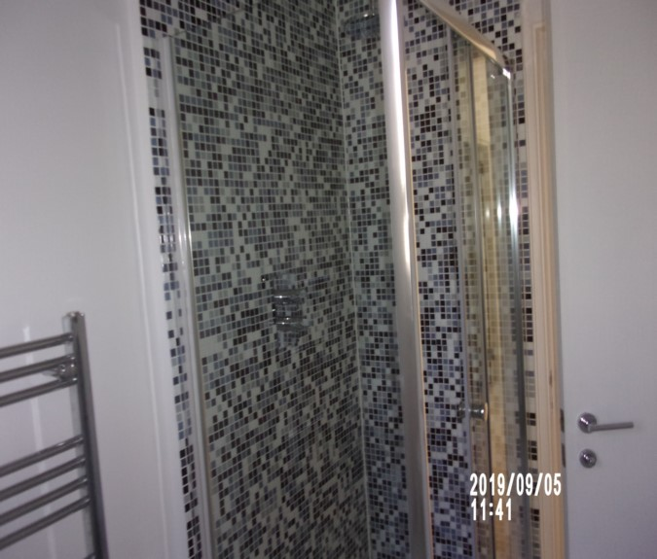

Bathroom Bathroom

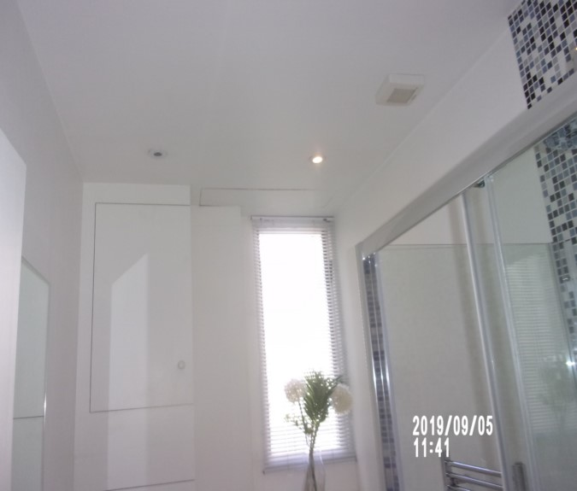 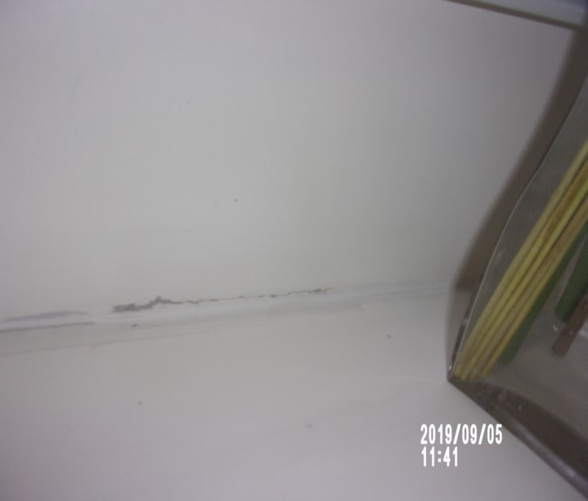

Window frame Boiler

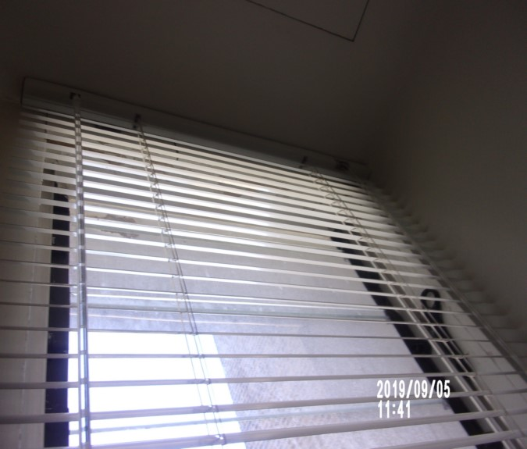 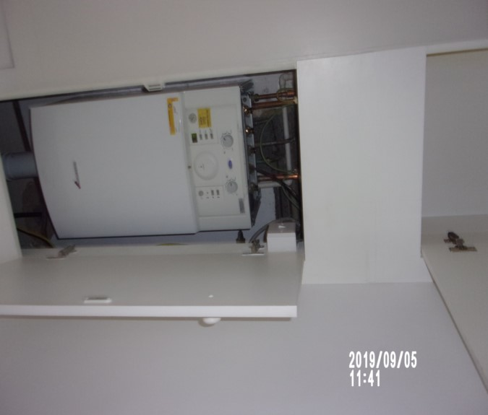

Boiler cupboard

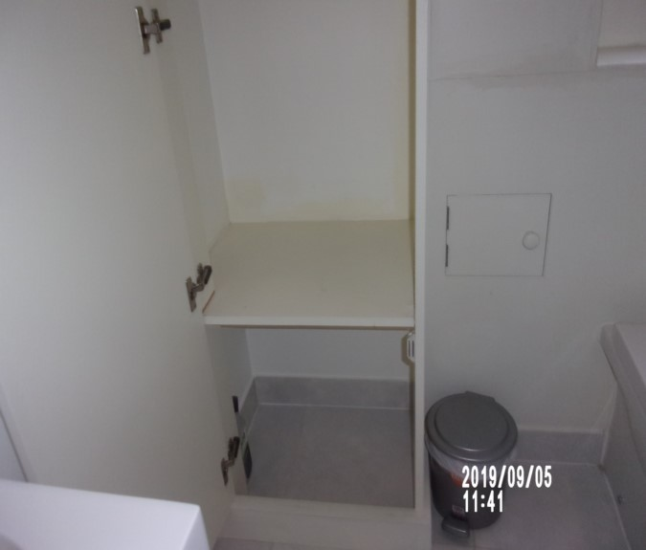

# BEDROOM 1

|  |  |  |  |  |
| --- | --- | --- | --- | --- |
| **Door** | Wood painted white door  White painted wooden frame work  Stainless steel handle either side | 1 or 2 x light scuff marks seen to both left and right hand side exterior door  1 or 2 x chips seen to the door right hand side at an angle  Black smudge marks exterior low level  Exterior door chipping seen to the bottom edge at an angle |  |  |
| **Ceiling** | Painted white with white painted coving | Cracking above door |  |  |
| **Walls** | Part green and tree design paper  Part painted green | Some light shading seen to walls, most notably rear facing wall at mid level  Not fully inspected behind any furniture |  |
|  | Back wall:  1 x brushed steel single dimmer switch | 1. Chip low level under mirror  2. Black few feint marks around mirror |  |

# BEDROOM 1

|  |  |  |  |
| --- | --- | --- | --- |
| **Walls contd..,** | Left hand side wall: |  |  |
|  | Facing wall:  2 x brushed steel double sockets  1 x brushed steel single telephone point | Chip low level by bed |  |
| **Woodwork** | Wood painted white | Black marks to front wall  Light scuffing in places |  |
| **Flooring** | White and grey pin stripe carpet | Not inspected below furniture  Few small shaded marks seen forward entrance  Vacuumed for the ~~start~~ end of tenancy |  |
| **Lighting** | 7 x ceiling mounted spots with white surrounds | 1. All working order  All tested for power |  |
| **Heating** | 1 x white metal double panelled radiator with grille to top | 1. Valves complete  Intact and in good order |  |

# BEDROOM 1

|  |  |  |  |
| --- | --- | --- | --- |
| **Window** | White wood framed single glazed sash unit  1 x stainless steel twist lock  2 x white metal finger pulls | 1. Glazing is slightly soiled to exterior  Glazing clean to interior |  |
| **Blind** | 1 x white black out roller blind with brushed steel beaded pulley | 1. Working order  Scuffing and light usage marks seen at mid level |  |
| **Bed** | White wood laminate king size bed base  Wall mounted black leather headboard  1 x white and black stripe king size mattress | Partly dressed – Not closely inspected  FFR label not seen  Mattress to the top surface appears to be good order  Only inspected 1/3 up as bed is dressed |  |

# BEDROOM 1

|  |  |  |  |
| --- | --- | --- | --- |
| **Bedside tables** | 2 x dark wood laminate bases and glass to top | Light scratches seen to the top surface |  |
| **Mirror** | Wall mounted black glass framed bevelled edge mirror | Surface scratches |  |
| **Lamps** | 2 x white and stainless steel angle poised lamps | 1 x working  1 x no bulb |  |
| **Shelves** | 4 x white painted wooden open shelves | General signs of usage with dust build-up |  |
| **Fitted wardrobe** | 4 x white painted wooden doors  Stainless steel pulls to each door | Light signs of usage includes light scuff marks and rub marks in places |  |
| **Wardrobe 1** | 2 x white painted shelves  1 x stainless steel hanging rail  1 x strip light | 1. Light in working order  Pull slightly loose |  |

**BEDROOM 1**

|  |  |  |  |
| --- | --- | --- | --- |
| **Wardrobe 2** | 3 x white painted shelves  1 x stainless steel hanging rail  1 x strip light | Tested and working |  |
| **Wardrobe 3** | 2 x white painted shelves  1 x stainless steel hanging rail  1 x strip light | Working  Chipping to shelf edge |  |
| **Wardrobe 4** | 3 x white painted shelves  1 x strip light | Working |  |
| **Linen** | White flat sheet  2 x red cushions – 1 x in bedroom 2  1 x light blue blanket  1 x cream woollen throw – in bedroom 2 |  |  |
| **Electrical equipment** | Samsung Virgin box  DAC DVD player  3 x Samsung speakers  In reception | Not tested |  |
| **Pillows** | 2 x white pillows  3 x grey scatter cushions  1 x white duvet cover  1 x duvet |  |  |
| **Additional** | White folding chair |  |  |

Bedroom 1 Bedroom 1

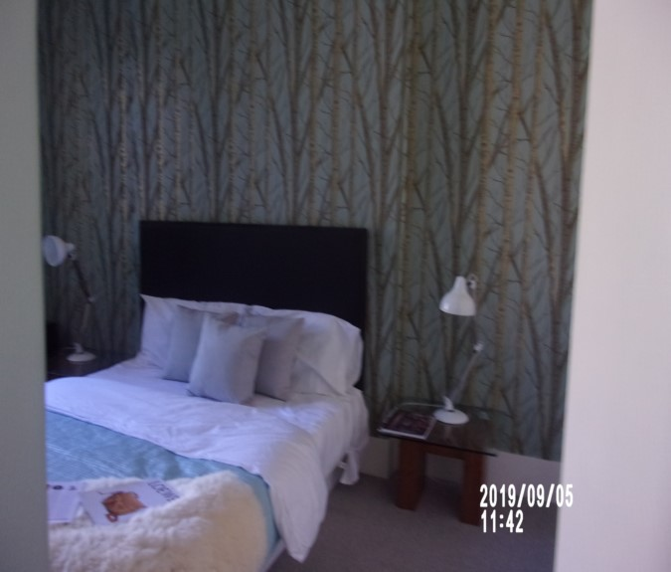 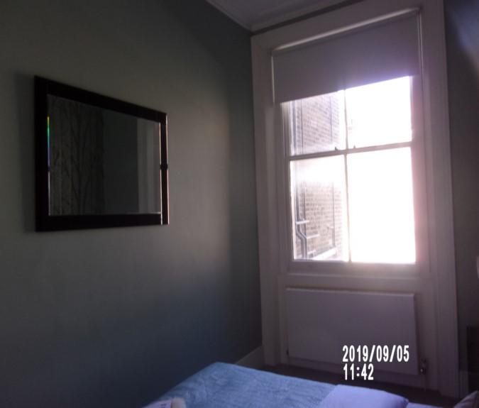

Bedroom 1 Bedroom 1

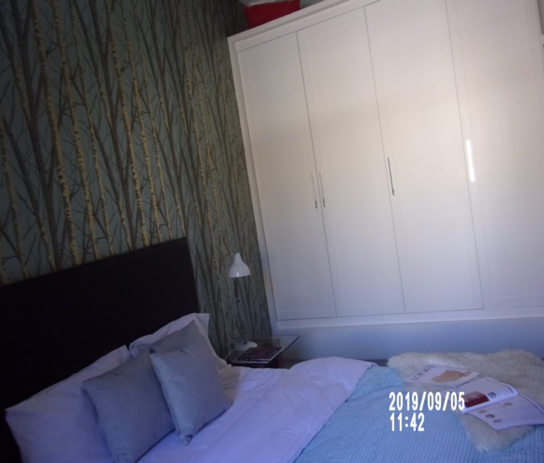 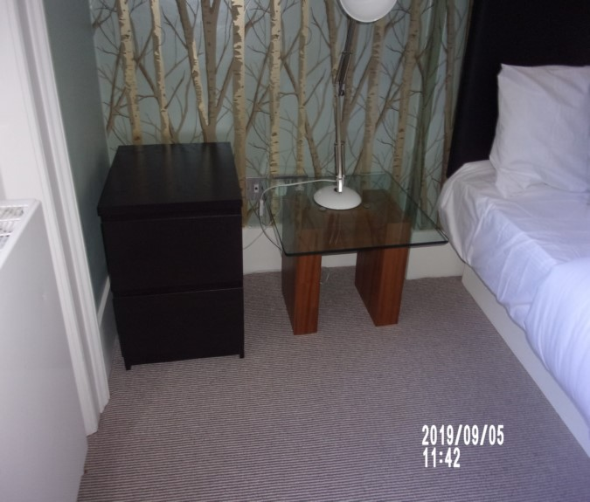

Bedroom 1 Wardrobe

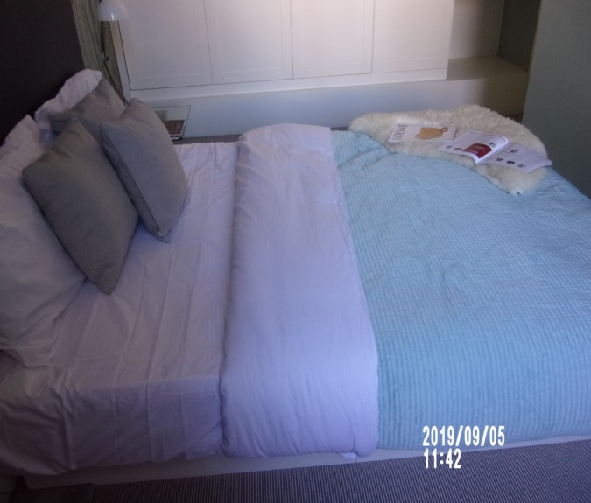 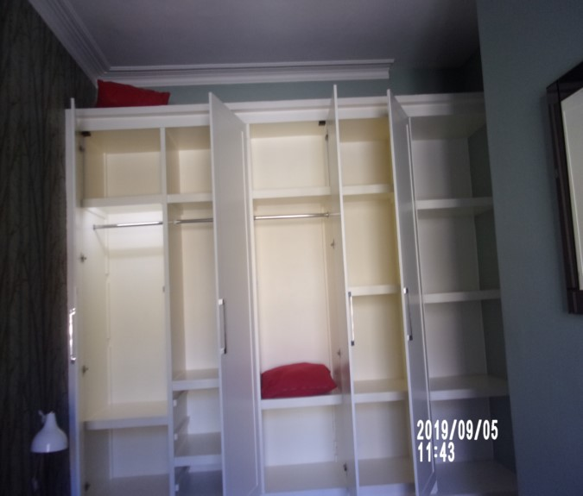

# KITCHEN / RECEPTION

|  |  |  |  |  |
| --- | --- | --- | --- | --- |
| **Door** | Wood painted white  White painted wooden frame work  Stainless steel handle to either side | Exterior frame some light chipping seen at an angle  Shading seen to both left- and right-hand side exterior door  Scuffing seen at low level  Interior door inner edges scattered shading seen around the edges of the frame left hand side at mid to low level  Exterior door some light rub marks seen at low level  Very tiny nick exterior mid level |  |  |
| **Ceiling** | Painted white with white painted coving | Some light grey shading in places  Painted over defects above left hand side wall coving to corner  Stress crack above fridge |  |  |
| **Walls** | Part painted white  Part glass splash back  Part white tree design paper | Some light rub marks seen at mid to low level, most notably front facing wall  Painted over infill patch to facing wall at high level  Few filled small splash type marks high level  Not inspected behind any furniture |  |

**KITCHEN / RECEPTION**

|  |  |  |  |
| --- | --- | --- | --- |
| **Walls contd...** | Back wall:  2 x brushed steel and white plastic double sockets  1 x brushed steel and white plastic 4-way dimmer switch | Water type swirl marks visible |  |
|  | Left hand side wall:  2 x brushed steel and white plastic double sockets | Scratch at high level |  |
|  | Facing wall:  1 x brushed steel and white plastic double socket  1 x white painted vent | 1. Drip stain  2. Dark marks low level  3. Few minor angle rubs  Stress crack right hand side of mirror |  |
|  | Right hand side wall |  |  |
| **Woodwork** | Wood painted white | Light scuffing seen in places |  |

**KITCHEN / RECEPTION**

|  |  |  |  |
| --- | --- | --- | --- |
| **Flooring** | White wood laminate | 1. Couple of scattered light scuffs  2. Scratch forward of oven  3. 3 x Chips to rear  Unable to fully inspect underneath any furniture  Vacuumed for the ~~start~~ end of tenancy |  |
| **Lighting** | 7 x ceiling mounted spots with white surrounds  2 x under unit mounted spots with brushed steel surrounds | Ceiling mounted recessed spotlights ~~1~~ 2 x not currently showing power  1. All bulbs working |  |
| **Heating** | 1 x white metal double panelled radiator with grill to top | 1. Valves complete  2. Slightly scratched and marked left hand side |  |
| **Window** | White wood frame single glazed sash unit  2 x stainless steel finger pulls  1 x stainless steel twist lock | 1. Glazing is slightly soiled to exterior  2. Couple of minor marks to frame work of right hand side  Some light grey shading seen around the edges |  |

**KITCHEN / RECEPTION**

|  |  |  |  |
| --- | --- | --- | --- |
| **Blind** | 1 x white roller blind with brushed steel beaded pulley  Chain break seen but no general usage pulley anchor | Appears to be intact  Chain break in place |  |
| **Units** | White wood laminate fascia’s  Brushed steel pulls  Concealed lighting low level | Clean  Working order  All clean to both interior and exterior |  |
| **Wall unit 1** | Single unit  Interior:  3 x shelves |  |  |
| **Wall unit 2** | Single unit  Interior:  3 x shelves |  |  |
| **Wall unit 3** | Single unit  Interior:  3 x shelves |  |  |
| **Wall unit 4** | Single unit  Interior:  3 x shelves |  |  |

**KITCHEN / RECEPTION**

|  |  |  |  |
| --- | --- | --- | --- |
| **Base unit 1** | Single unit  Interior:  1 x shelf |  |  |
| **Base unit 2** | Single unit under sink  Interior:  1 x shelf |  |  |
| **Base unit 3** | Fascia to the dishwasher |  |  |
| **Base unit 4** | 1 x Drawer ~~with grey cutlery insert~~  Single unit  Interior:  1 x shelf |  |  |
| **Worktop** | Light wood | Heavy staining seen to the worktop |  |

**KITCHEN / RECEPTION**

|  |  |  |  |
| --- | --- | --- | --- |
| **Sink** | Stainless steel sink  Stainless steel mixer tap | 1. Few scattered light surface scratches and water stain  2. Tested and working |  |
| **Dishwasher** | Integrated Lamona dishwasher  Serial no: 12-503820-08  2 x white coated wire crockery shelves  1 x white and grey plastic cutlery basket with handle | Tested and working  ~~Clean to interior~~ final wipe required  Door benefit from polish  Kitchen item to interior |  |
| **Hob** | Black Lamona electric hob | 1. Surface scratches  2. Tested and working |  |
| **Extractor fan** | Integrated grey | 1. Working order  2. Light in working order  3. Tested and working  ~~Clean~~ Grease spots to unit |  |

**KITCHEN / RECEPTION**

|  |  |  |  |
| --- | --- | --- | --- |
| **Oven** | Brushed steel and black Lamona oven  Serial no: J0QF7DBC900312A  Interior:  1 x stainless steel wire shelf  2 x grey plastic controls | Power seen  Clean to interior |  |
| **Fridge freezer** | Integrated Lamona Fridge/Freezer  Serial no: 1201504708  Fridge:  4 x door shelves  3 x glass and white plastic shelves- 1 x without white edge  2 x clear plastic salad trays  1 x stainless steel bottle shelf  1 x white and clear plastic light cover  Freezer:  1 x clear plastic freezer flap  2 x white and clear plastic drawers | 1. Light in working order  1 x freezer drawer has hairline crack  Final wipe required front of salads crisper |  |
| **Miscellaneous** | ~~2~~ 6 x white bowls  ~~2~~ 7 x white side plates  ~~2~~ 8 x dinner plates  ~~3~~ 4 x wineglasses  5 x soup bowls |  |  |

**KITCHEN / RECEPTION**

|  |  |  |  |
| --- | --- | --- | --- |
| **Cutlery** | 4 x stainless steel spoons  4 x stainless steel knives  1 x stainless steel fork  4 x stainless steel tea spoons  Additional seen |  |  |
| **Contents** | 1 x grey and black granite chopping board  ~~3 x wooden spoons~~ | ~~In use~~ |  |
| **Utensils** | Bottle opener  Pair of scissors  ~~1 x bottle opener~~  ~~1 x strainer~~  ~~2 x black handled knives~~  ~~1 x white plastic measuring spoon~~ | ~~Used~~ |  |
| **Additional** | Kitchen, utensils, pots, frying pans, glasses |  |  |
| **Dining table** | White wood laminate based with glass top | Light scratches seen in places  Clean to the top surface |  |
| **Dining chairs** | Now 4 x dark wood pale grey velvet chairs | Appears to be shoe sole prints on 2 x seats |  |
| **Side tables** | 1 x white plastic bases and grey granite tops | Appears to be in good used order |  |

**KITCHEN/ RECEPTION**

|  |  |  |  |
| --- | --- | --- | --- |
| **Coffee table** | White wood laminate | 1. Few scattered scuffs to top  2. Couple of angle chips  Chipping seen around the edges  1 or 2 x light scratches seen to the top surface |  |
| **Sofa** | Grey velvet 2-seater sofa  2 x back and 2 x seat cushions | Good order |  |
| **Cushions** | 3 x Red scatter cushions  4 x Grey scatter cushions |  |  |
| **Mirror** | Wall mounted mirror framed bevelled edge mirror | 1. Cracked to bottom left corner  Clean to the top surface |  |

**KITCHEN / RECEPTION**

|  |  |  |  |
| --- | --- | --- | --- |
| **Print** | 1x wall mounted black plastic framed | 1. Light wear to the edge of 1 |  |
| **Shelves** | 2 x wall mounted white painted  wooden | 1 or 2 x light marks consistent with use |  |
| **Tray** | 1 x wooden tray | Marks consistent with ageand style |  |
| **TV** | 1 x wall mounted Bravia Sony TV on black metal wall bracket | Not tested |  |
| **Items** | Sony DVD player and remote  Sky HD box and remote  Sky router  Panasonic telephone and base  1 x more remote |  |  |

**KITCHEN / RECEPTION**

|  |  |  |  |
| --- | --- | --- | --- |
| **Storage cupboard** | Double door storage cupboard with white painted wood  1 x stainless steel pull  Interior:  1 x white painted wooden shelf  Cabling and stand for TV  Assorted to interior  Selection of extension leads (see picture) | Assortment of items to interior unable to fully inspect |  |
| **Lamp** | 1 x stainless steel-based floor lamp with white glass shade | Tested and working for power |  |
| **Heat alarm** | 1 x white plastic ceiling mounted heat alarm | 1. Not tested due to height  2. Green light seen |  |
| **Vase** | 1 x glass vase  1 x white glass vase with faux flowers  1 x stainless steel with candle  1 x glass vase with faux flowers | Empty |  |
| **Manual** | Sony TV |  |  |

Reception Reception

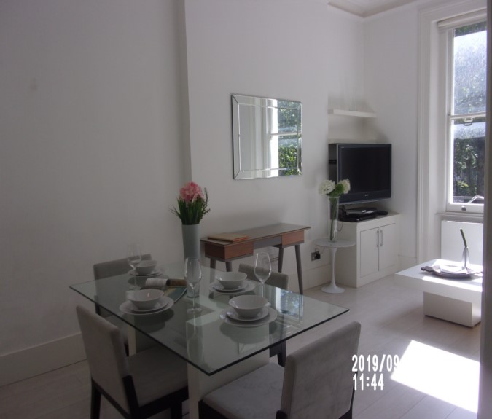 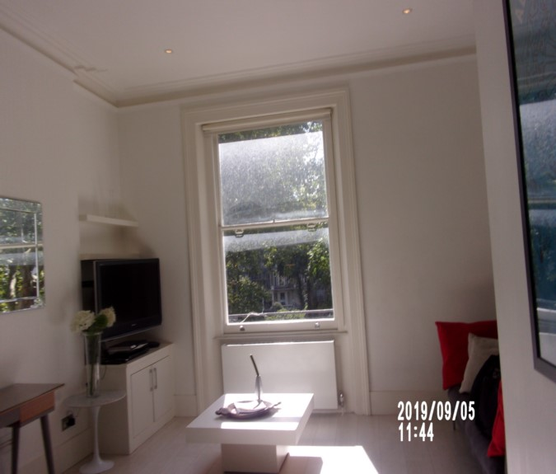

Reception Reception

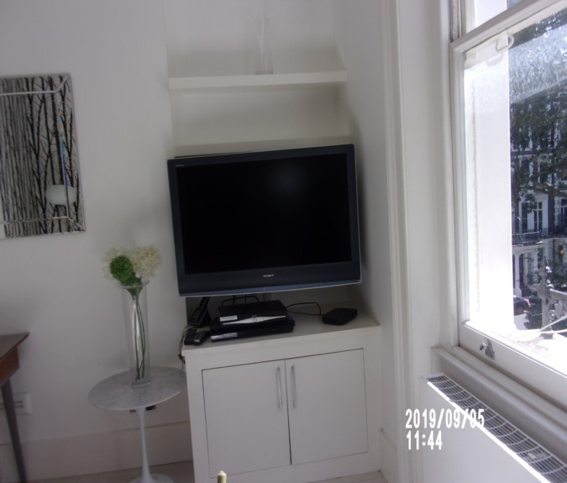 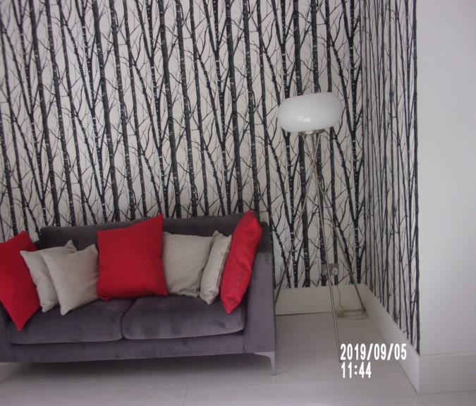

Items in cupboard Wall reception hole screw

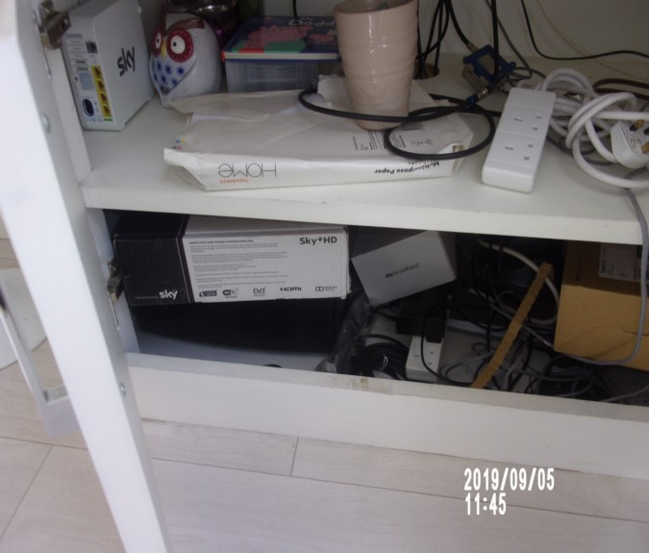 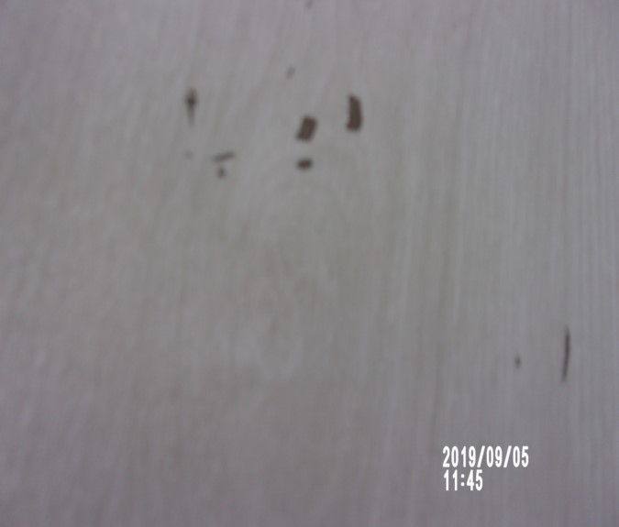

Shoe prints possibly on chair seat Kitchen

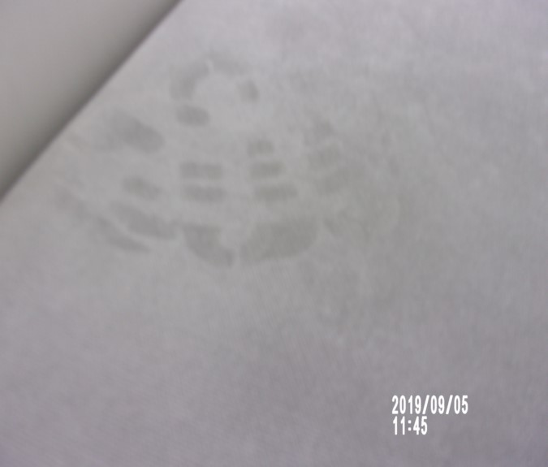 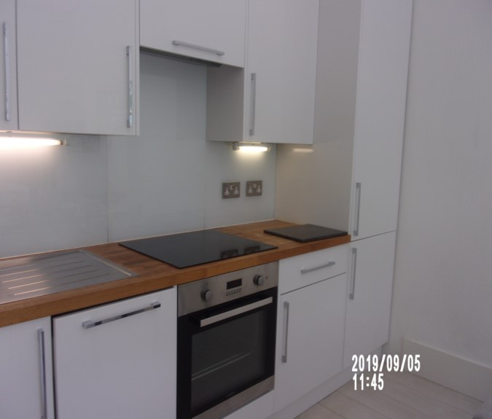

Kitchen Infill patch to wall

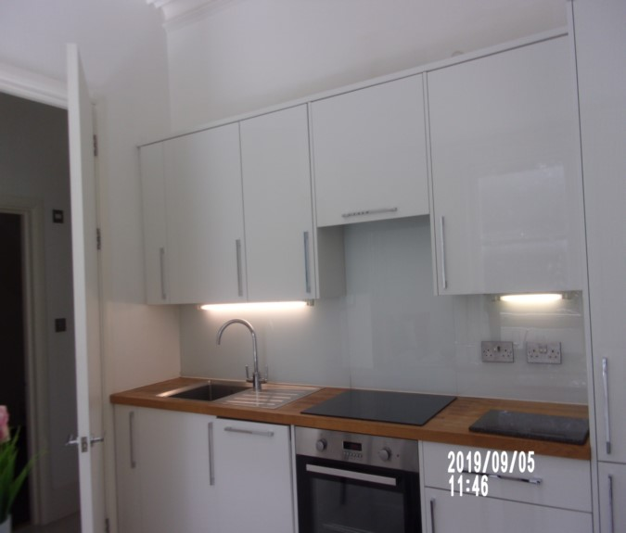 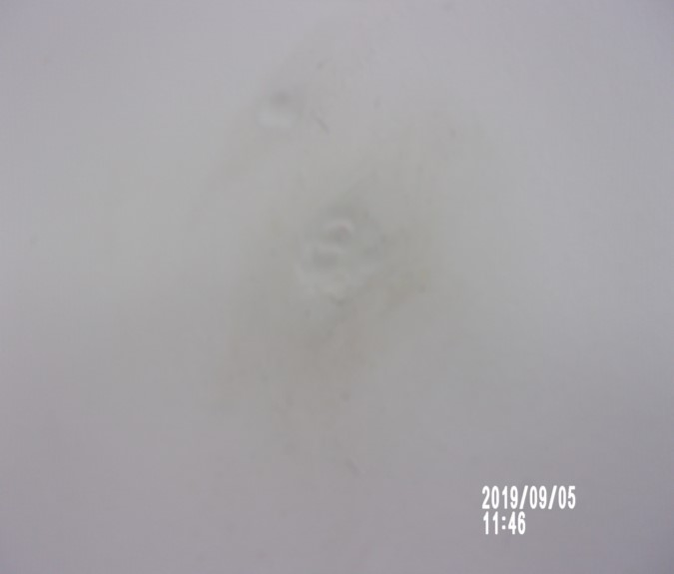

Fridge/ freezer items in drawer

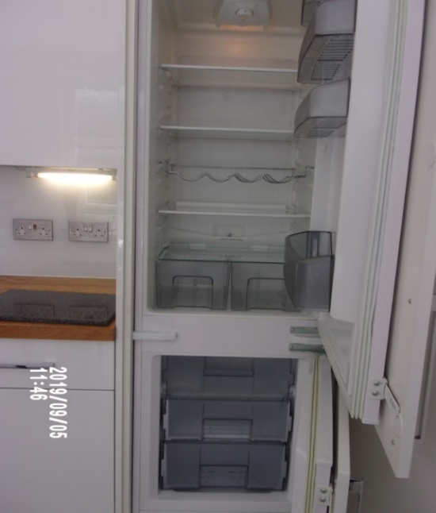 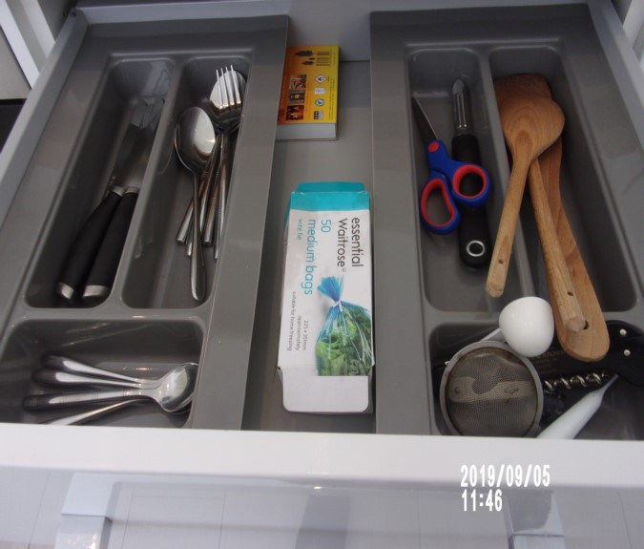

Hob Extractor hood

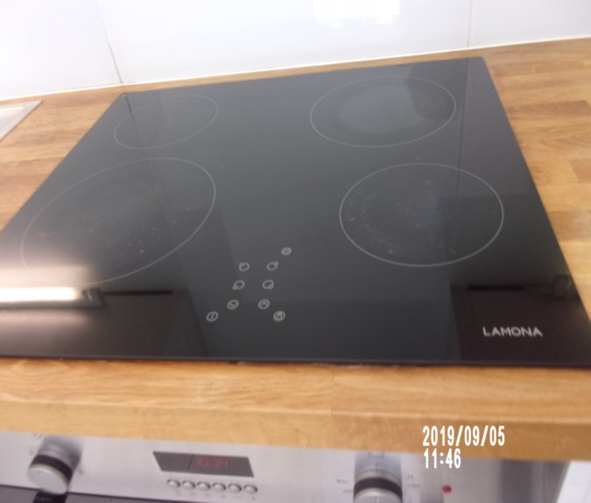 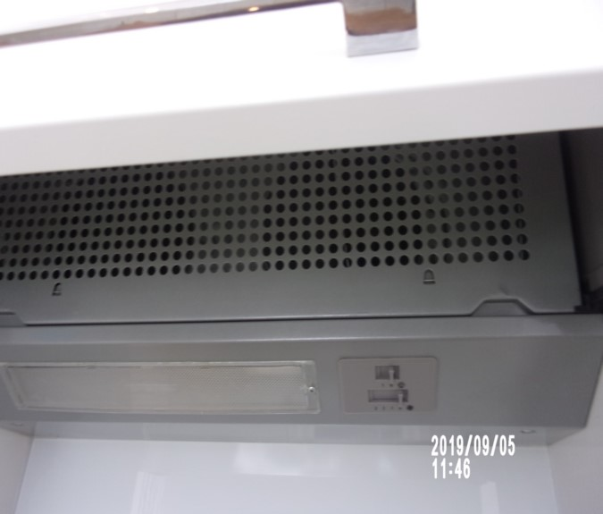

Sink Worktop

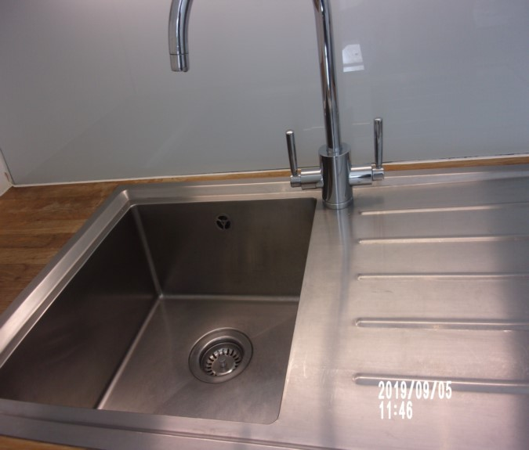 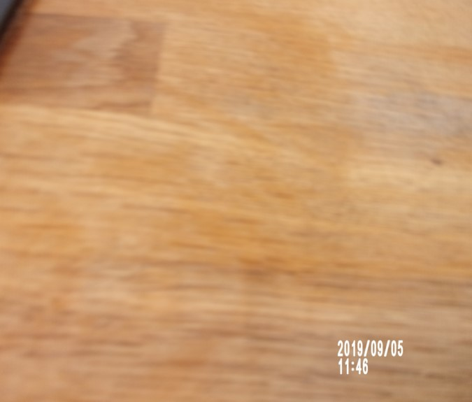

Oven Dishwasher

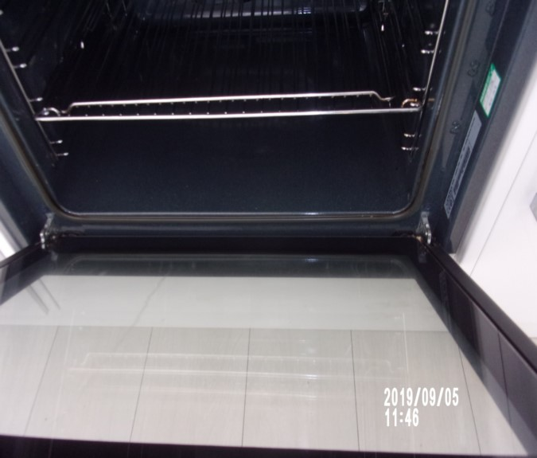 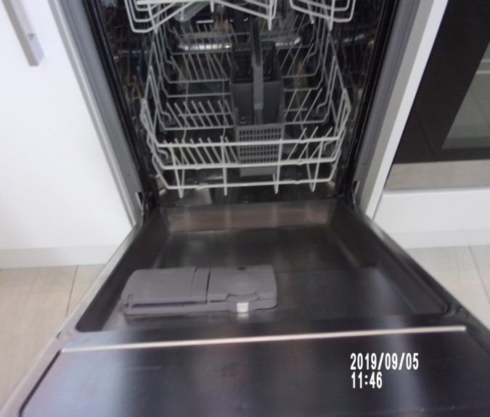

Under sink Reception

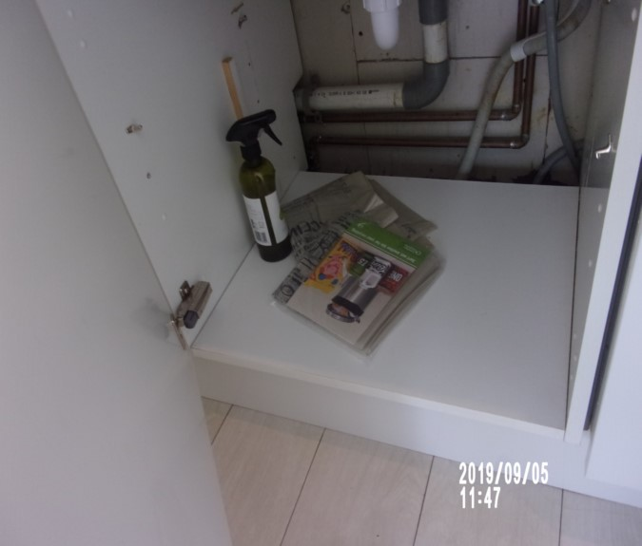 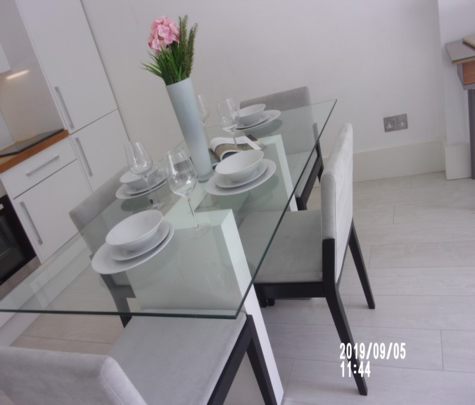

**BEDROOM 2**

|  |  |  |  |  |
| --- | --- | --- | --- | --- |
| **Door** | Wood painted white door  White painted wooden frame work  Stainless steel handle either side | Exterior frame 1 or 2 x light rub marks seen at low level  Exterior door some light finger soil marks and light scuffing in places  Small chip to base interior  1 or 2 x light scuff marks seen door and frame both interior and exterior  Exterior door chipping seen to the bottom edge at an angle |  |  |
| **Ceiling** | Painted white with white painted coving | Light grey shading seen in places  Some light chipping around recessed spotlight  Appears to be intact |  |  |
| **Walls** | Painted white | Rub marks light at mid to low levels seen to all walls, quite heavy to left hand side wall  Unable to fully inspect behind any furniture |  |

**BEDROOM 2**

|  |  |  |  |
| --- | --- | --- | --- |
| **Walls contd...** | Back wall:  1 x brushed steel double socket  Inset cupboard door to high level | 1. Cupboard not closing  2. Chip over bed  3. Angle chips  Water drips by bed post |  |
|  | Left hand side wall:  1 x brushed steel double socket  1 x brushed steel single telephone point  1 x brushed steel single TV point | 1. Black marks by window |  |
|  | Facing wall: | 2 or 3 x indents mid level |  |
|  | Right hand side wall  1 x brushed steel double socket | 1. Several light scuffs |  |
| **Woodwork** | Wood painted white | Not fully inspected ~~throughout~~  General usage  ~~1 or 2 x~~ Light scuff marks seen |  |

**BEDROOM 2**

|  |  |  |  |
| --- | --- | --- | --- |
| **Flooring** | White and grey pin stripe carpet | Not inspected below furniture  Few marks by window  Vacuumed for the ~~start~~ end of tenancy |  |
| **Lighting** | 6 x ceiling mounted spots with white surrounds | 1 x light not currently showing power |  |
| **Heating** | 1 x white metal double panelled radiator with grille to top | 1. Valves complete  Slightly bent to the top surface |  |
| **Window** | White wood framed single glazed sash unit  1 x stainless steel twist lock  2 x stainless steel finger pulls | 1. Glazing is slightly soiled to exterior  Clean to interior |  |
| **Blind** | 1 x white black out roller blind with brushed steel beaded pulley  Chain break seen but no anchor seen | 1. Working order  Some scuffing and rub marks seen in places  Torn to rear at low level |  |

**BEDROOM 2**

|  |  |  |  |
| --- | --- | --- | --- |
| **Bed** | Dark wood 4-poster king size bed with 5 frame work struts to the top  1 x white and black stripe king size mattress | 1. Angle chips to posts  2. Chip to base panel  3. Mattress ~~not inspected as bed dressed~~ in use |  |
| **Bedside tables** | 2 x white wood laminate bases and glass to top  1 x drawer  1 x stainless steel pull | Some light circular staining seen to the top surface |  |
| **Scatter cushions** | 2 x Red scatter cushions seen in wardrobe | Seen in cupboard  Both appear to be in good used order |  |
| **Lamps** | 2 x white and stainless steel angle poised lamps | 1 x tested and working  1 x has no bulb |  |
| **Print** | Black plastic framed print of New York Times page | Intact |  |
| **Fitted wardrobe** | 6 x light wooden doors  Brushed steel pulls to each door | 1. Not inspected to high level due to height  Unable to fully inspect units at high level  Marks consistent with use to interior |  |

# BEDROOM 2

|  |  |  |  |
| --- | --- | --- | --- |
| **Wardrobe 1 – low level** | 1 x white painted shelf  1 x stainless steel hanging rail |  |  |
| **Wardrobe 2 – low level** | 4 x white painted shelves |  |  |
| **Wardrobe 3 – low level** | 2 x white painted shelves  1 x stainless steel hanging rail  1 x strip light | 1. Possibly not working |  |
| **Linen** | 1 x Cream fleece throw | All in use |  |
|  | 3 x mottled cream scatter cushions  1 x purple quilted throw  1 x white flat sheet  1 x white duvet  Appears to be in wardrobe high shelf  1 x white duvet cover – on bed  2 x pillows in white covers – One on bed and one in wardrobe |  |  |
| **Additonal** | Dark wood unit | Back panel is loose |  |

Bedroom 2 Bedroom 2

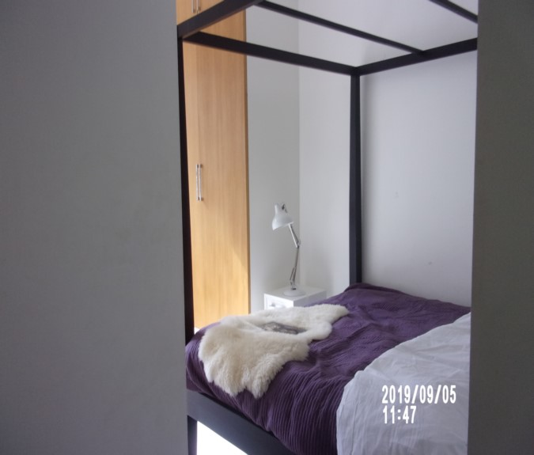 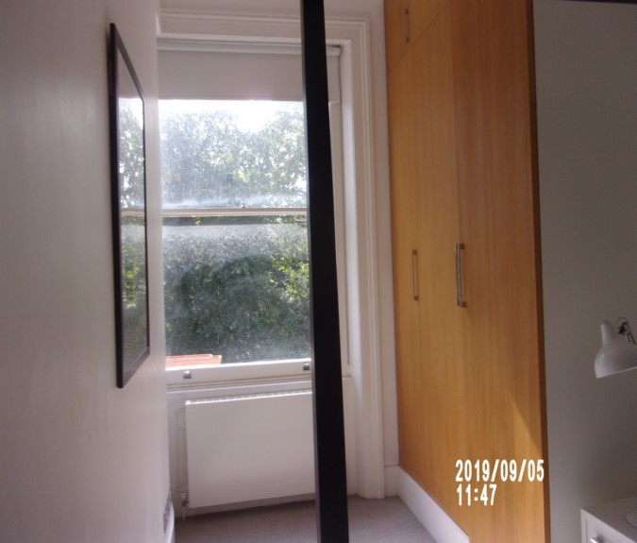

Wardrobe Items in cupboard

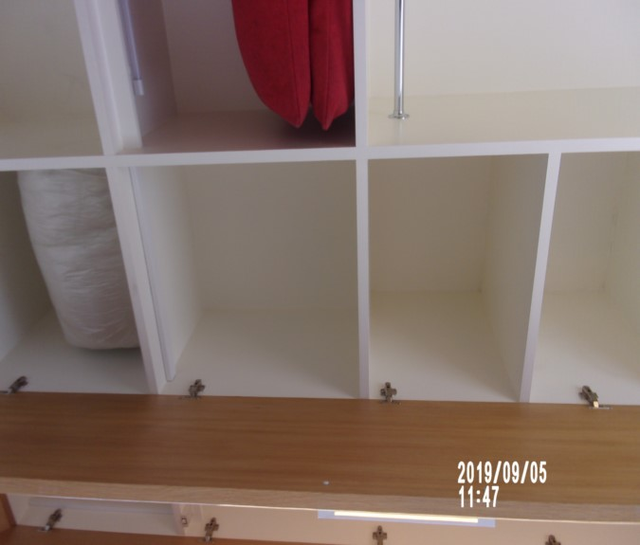 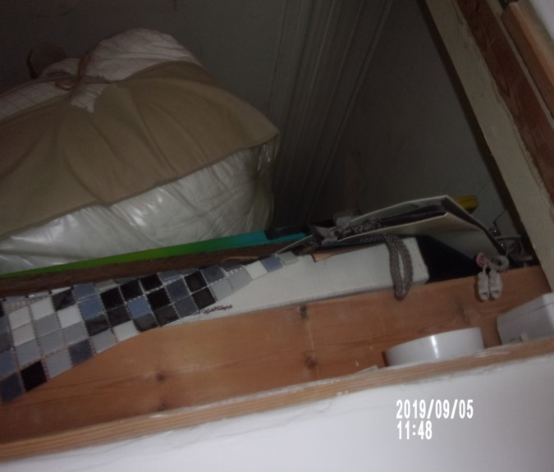

Water drips to wall

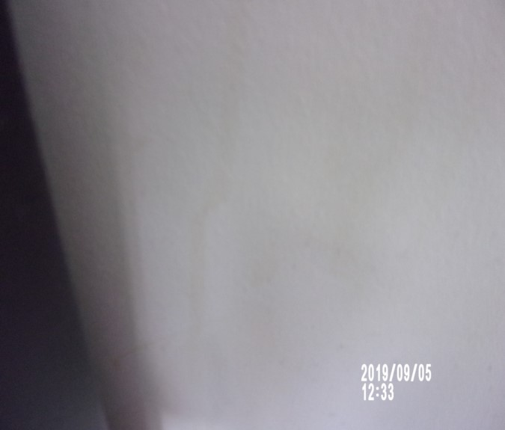

**BATHROOM 2**

|  |  |  |  |  |
| --- | --- | --- | --- | --- |
| **Door** | Wood painted white door  White painted wooden frame work  Stainless steel handle and lock either side | Good order  Exterior door1 or 2 x chips seen to the bottom edge at an angle |  |  |
| **Ceiling** | Painted white | Intact  1 or 2 x light scuff marks seen  Stress crack near vent |  |  |
| **Walls** | Part painted white  Part small grey tiling  Part mirrored panelling | Discolouration seen to grout  Some light rub marks seen in places |  |
|  | Right hand side wall:  1 x white plastic shaving socket |  |  |
| **Woodwork** | Dark grey tiling |  |  |

**BATHROOM 2**

|  |  |  |  |
| --- | --- | --- | --- |
| **Flooring** | Square dark grey ceramic tiling  1 x stainless steel and black rubber door stop behind the door | Vacuumed for the ~~start~~ end of tenancy |  |
| **Lighting** | 4 x ceiling mounted spots with white surrounds | ~~2~~ 1 x lights not currently showing power |  |
| **Heating** | 1 x stainless steel ladder style radiator | Clean to the top surface |  |
| **Basin** | White corian basin  Stainless steel pop up plug  Stainless steel mixer tap  White wood laminate single drawer mounted beneath | 1. Tap in working order  Tested and working / clean  Clean to interior |  |
| **WC** | White pedestal WC with exposed cistern  White plastic seat and lid  Stainless steel double flush | Tested and working / ~~clean~~ light residue to interior |  |

**BATHROOM 2**

|  |  |  |  |
| --- | --- | --- | --- |
| **Shower** | White plastic bath  Grey ceramic tiled bath panel  Wall mounted stainless steel shower control plaque  Stainless-steel pop-up plug and tap spout and overflow  Wall mounted stainless steel shower head  Glass and stainless-steel shower screen with clear plastic trim to base | Tested and working / clean  All attachments in good clean order  Pop up control not working |  |
| **Extractor fan** | White plastic ceiling mounted Vent-axia extractor | Not tested |  |
| **Toilet roll holder** | 1 x wall mounted stainless steel | Intact |  |
| **Mirror** | 1 x wall mounted unframed mirror over basin | Clean to the top surface  Odd water spots low level |  |

**BATHROOM 2**

|  |  |  |  |
| --- | --- | --- | --- |
| **Miscellaneous items** | Plastic now loo brush and holder  Circular marble top table as reception  Glass circular ribbed pot – In reception  Black floor standing ceramic vase  ~~1 x red/ grey plunger~~ | Intact  Intact and in good order  In good order  Good clean order  Chip to top |  |

Bathroom 2 Bathroom 2

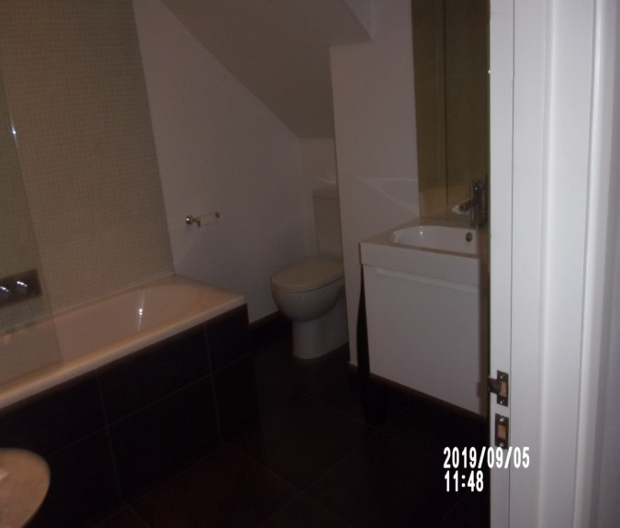 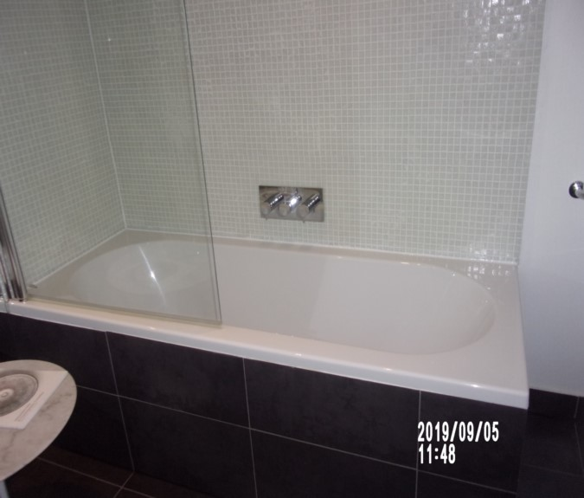

Bathroom 2 Bathroom 2

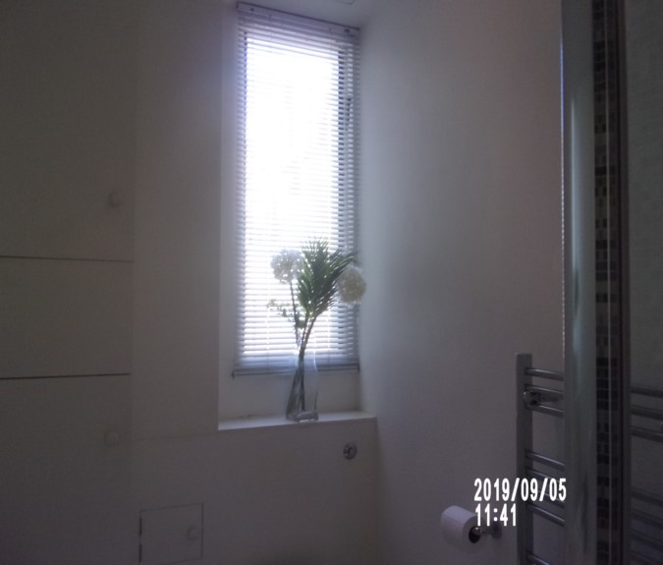 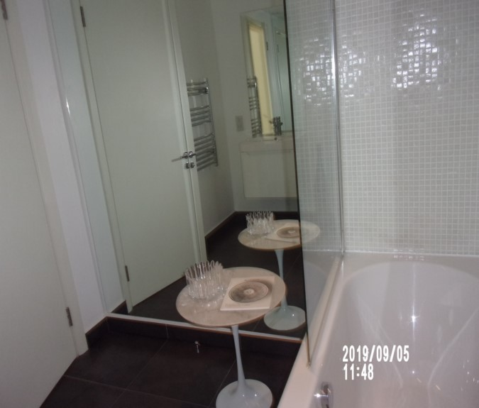

Crack vase Bathroom 2

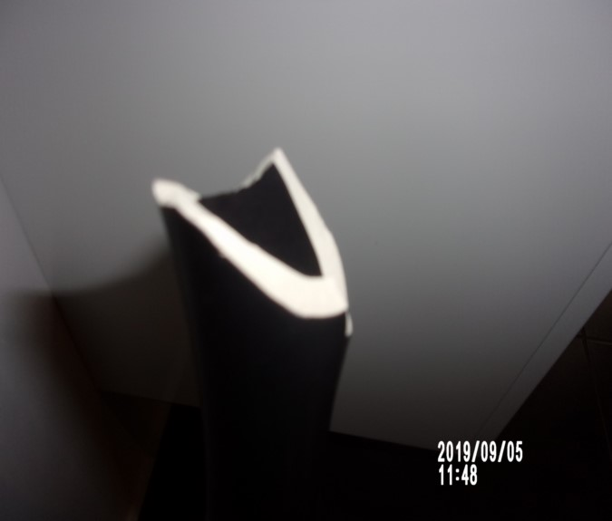 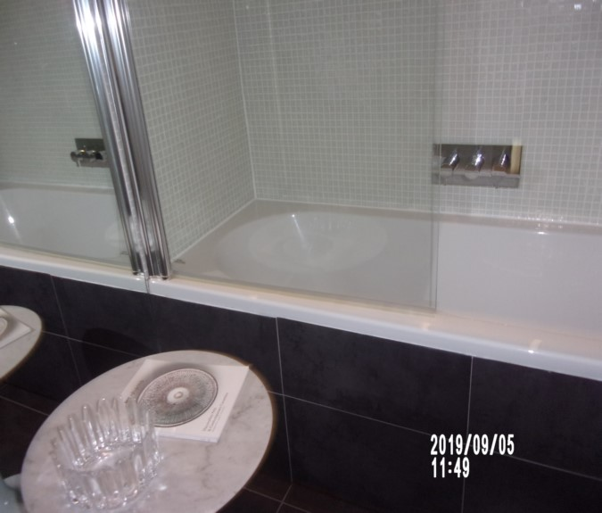

# DECLARATION AT CHECK IN

This inventory has been examined and, subject to marginal comments found to be correct.

## On behalf of the landlord

**on behalf of the tenant**

**commencement of tenancy**

## N.B

This inventory is correct to the best of our knowledge but advise you to examine its contents prior to signing, as we can not be held responsible for any errors or omissions. Descriptions are for identification purposes only.

The relevant utility companies must check all meter readings, as we can not be held responsible for any discrepancies

Please ensure that all items listedin this inventory are in the same location at the end of the tenancy.

ADDITIONAL AMENDMENTS

|  |  |  |
| --- | --- | --- |
| **DATE** | **DESCRIPTION OF CHANGES** | **AGENTS/LANDLORD SIGNATURE** |
|  |  |  |
|  |  |  |
|  |  |  |
|  |  |  |
|  |  |  |
|  |  |  |
|  |  |  |
|  |  |  |
|  |  |  |

WHEN ADDITIONS/AMENDMENTS ARE MADE BY THE LANDLORD, TENANT OR AGENT THE RELATIVE PARTIES MUST BE INFORMED

GENERAL COMMENT

It should be noted that it is not the responsibility of the Inventory Clerk toopen, unpack, empty or itemise items stored in carrier bags or other containersunless it is made specifically clear they are the property of the Landlord.

|  |
| --- |
| **CHECK IN REPORT OF CONDITION AT: DATE:** 05/09/ 2019 |

|  |  |
| --- | --- |
| **PROPERTY ADDRESS:** | Flat C  47 Courtfield Gardens  Kensington  SW5 0NA |
| **CLIENT:** | London Central Portfolio |
| **CONTACT:** | Olivia Highwood |

|  |  |  |
| --- | --- | --- |
| **ELECTRIC** | **GAS** | **WATER** |
| **METER NUMBER:**  S68A03447 | **METER NUMBER:**  344253S | **METER NUMBER:**  Not located |
| **READING:**  32459 | **READING:**  8784 | **READING:**  None |
| **LOCATION:**  Communal hallway cupboard | **LOCATION:**  Basement vault | **LOCATION:**  Not located |

|  |  |  |  |  |  |  |
| --- | --- | --- | --- | --- | --- | --- |
| **PROPERTY DESCRIPTION** | | | | | | |
| **ROOM** | **QTY** | **ROOM** | | **QTY** | **EXTERIOR AREAS** | **QTY** |
| RECEPTION -KITCHEN | 1 | BATHROOMS | | 2 | FRONT GARDEN | 0 |
| OFFICE | 0 | WC | | 0 | REAR GARDEN | 0 |
| BEDROOMS | 2 | UTILITY | | 0 | SWIMMING POOL | 0 |
| DRESSING ROOM | 0 | STORE ROOM | | 0 | GARAGE | 0 |
| STAIRCASE & LANDINGS | 0 | CELLAR | | 0 | ANNEX | 0 |
|  |  |  | |  |  |  |
| □ HOUSE □ FLAT | | | □ UNFURNISHED □ FURNISHED | | | |

|  |
| --- |
| **GENERAL SUMMARY** |

|  |  |  |
| --- | --- | --- |
| **GENERAL CONDITION** | □ Professionally cleaned for start of tenancy :-  □ Domestically cleaned for the start of tenancy :-  □ Further general cleaning required:-  □A full professional clean is required :- | **FURTHER COMMENTS** |
| **ODOUR** | □ Pet □ Smoking □ Cooking  □Musty | □N/a |
| **DECORATIVE ORDER / WOODWORK** | □Advised freshly painted  □Good Order  □ Defects as noted  □ Dusty  □Woodwork scuffed/chipped |  |
| **FLOORING** | □Professionally cleaned for start of tenancy  □Good Order□ Defects as noted  □ Vacuumed for start of tenancy  □Requires further cleaning □ New |  |
| **CURTAINS / BLINDS** | □ Professionally cleaned for start of tenancy  □ Vacuumed insitu for start of tenancy  □Requires further cleaning  □Defects as noted□Good Order | □N/A |
| **BLIND REGULATIONS** | □Chain break connector in place  □Chain Tidy in place  □Regulations not met | □N/A |
| **UPHOLSTERY** | □ Professionally cleaned for start of tenancy  □ Vacuumed insitu for start of tenancy  □Good Order  □ New □ Defects as noted | □ N/A |
| **FFR LABELS** | Sofa □ FFR Label Seen □ Label Not seen Armchair □ FFR Label Seen □ Label Not seen Pouffee □ FFR Label Seen □ Label Not seen  **Mattress:**  Bed 1 □ FFR Label Seen □ Label Not seen Bed 2 □ FFR Label Seen □ Label Not seen Bed 3 □ FFR Label Seen □ Label Not seen Bed 4 □ FFR Label Seen □ Label Not seen  **□ Client informed Name……………………….……** |  |
| **LINEN** | □ New □ In use □ None provided  □Domestically cleaned □ Freshly laundered | □ Requires further cleaning |
| **LIGHTS** | □ All working order  □ Bulbs missing / not working |  |
| **KITCHEN / APPLIANCES** | □ All clean order  □ All Appliances power tested  □Fridge left open power off □Freezer left open power off  □Fridgeleft shut power on □Freezer left shut power on | □ Requires further cleaning |
| **BATHROOMS/**  **WC** | □ Clean □ All fitments free of lime scale  □Water outlets tested and working | □ Mildew to areas as noted  □ Requires further cleaning |
| **WINDOWS** | □ Fitments complete  □ Clean to interior □Clean to exterior | □ Requires further cleaning |
| **GARDEN /**  **TERRACE/**  **BALCONY** | □ Seasonal order | □ N/A  □Further attention required |

|  |
| --- |
| **POSITION OF** |

|  |  |
| --- | --- |
| **STOP COCK** | Not located |
| **FUSE BOARD** | Hallway cupboard |
| **ALARM PANEL** | None |

|  |
| --- |
| **MANUALS PROVIDED** |
| **□** Washing machine □ Alarm □ TV □ Tumble Dryer □ Boiler □ Extractor hood  □ Dishwasher □ Microwave oven □ Oven  □ Fridge freezer □ Phone □ Waste disposal  □None provided |

|  |
| --- |
| **FIRE SAFETY** |

|  |  |
| --- | --- |
| **SMOKE ALARM 1** | □ Mains powered □ Power light on □ Too high to read □ Not visible  □**T**ested with Canned smoke and working order  □**Location: -** ……………………………………………………..  □**Expiry date** ………/…………/……..  **□ SMOKE ALARM NOT WORKING – Agentadvised**  Person advised: - Name ……………………………… |
| **SMOKE ALARM 2** | □ Mains powered □ Power light on □ Too high to read □ Not visible  □Tested with Canned smoke and working order  □**Location: -** ………………………………………………………….  □**Expiry date** ………/…………/……..  **□ SMOKE ALARM NOT WORKING – Agentadvised**  Person advised: - Name ……………………………… |
| **SMOKE ALARM 3** | □ Mains powered □ Power light on □ Too high to read □ Not visible  □Tested with Canned smoke and working order  □**Location**: - ………………………………………………………………  □**Expiry date** ………/…………/……..  **□ SMOKE ALARM NOT WORKING – Agentadvised**  Person advised: - Name ……………………………… |
| **CARBON MONOXIDE ALARM** | □ Tested and working order □Light seen □N/a |

|  |  |  |  |
| --- | --- | --- | --- |
| **KEYS** | | | |
| **KEY TYPE** | **SERIAL NUMBER** | | **QTY** |
|  |  | |  |
|  |  | |  |
|  |  | |  |
|  |  | |  |
|  |  | |  |
| **KEYS RECEIVED BY:** □AGENT □TENANT □LANDLORD □CONCIERGE □BUILDER  □ Management keys used 1xbramah,1x yale□ None provided    *Tick as applicable | | | |
| **NAME PRINTED:**  **……………………………………………………..** | | **SIGNATURE :**    **…………………………………………………….** | |

*N.B – Heavy items will not be moved or inspected behind/under, for health & safety reasons. We will not be held liable should any damages/stains/marks be found during the tenancy in these areas. Should the occupant find any of the above they should, inform the landlord/agent immediately and if/where possible take photographic evidence and pass to the relevant parties.

|  |  |  |
| --- | --- | --- |
| **CLIENT CALLED AT** | | |
| **TIME:** | **VOICE MESSAGE LEFT FOR:** | **SPOKEN WITH:** |

|  |  |  |
| --- | --- | --- |
| **IN ATTENDANCE AT CHECK IN** | | |
|  **INDEPENDENT CLERK**  ** TENANT**  ** LANDLORD**  ** AGENT** | **NAME PRINTED**    ……………………………………………… | **SIGNATURE**  ……………………………………..………….. |

|  |
| --- |
| **In attendance:** □LANDLORD □TENANT □INVENTORY CO. □RELOCATION REP |

|  |  |
| --- | --- |
| **NAME PRINTED**  ………………………………..……………… | **SIGNATURE**  ………………………………..……………….. |

|  |
| --- |
| **CHECK OUT REPORT OF CONDITION AT: DATE: 07**/09/2020 |

|  |  |
| --- | --- |
| **PROPERTY ADDRESS:** | Flat C  47 Courtfield Gardens  SW5 0NA |
| **CLIENT:** | London Central Portfolio |
| **CONTACT:** | Georgia Cole |

|  |  |  |
| --- | --- | --- |
| **ELECTRIC** | **GAS** | **WATER** |
| **METER NUMBER:**   1. S2BS 100 F00A 14425 2. 19L3830151 | **METER NUMBER:**  344253S | **METER NUMBER:**  Unknown |
| **READING:**   1. 61580 2. Credit mode balance 1324 | **READING:**  8925 | **READING:**  Unknown |
| **LOCATION:**  Communal hallway cupboard | **LOCATION:**  Basement Vault | **LOCATION:**  Unknown |
| **SUPPLIER:** | **SUPPLIER:** | **SUPPLIER:** |

**Both electric meters seen in cupboard**

|  |  |  |  |  |  |  |
| --- | --- | --- | --- | --- | --- | --- |
| **PROPERTY DESCRIPTION** | | | | | | |
| **ROOM** | **QTY** | **ROOM** | | **QTY** | **EXTERIOR AREAS** | **QTY** |
| RECEPTION -KITCHEN | 1 | BATHROOMS | | 2 | FRONT GARDEN | 0 |
| OFFICE | 0 | WC | | 0 | REAR GARDEN | 0 |
| BEDROOMS | 2 | UTILITY | | 0 | SWIMMING POOL | 0 |
| DRESSING ROOM | 0 | STORE ROOM | | 0 | GARAGE | 0 |
| STAIRCASE & LANDINGS | 0 | CELLAR | | 0 | ANNEX | 0 |
| STUDY | 0 | BALCONY | | 0 |  |  |
| □ HOUSE □ FLAT | | | □ UNFURNISHED □ FURNISHED | | | |

|  |
| --- |
| **GENERAL SUMMARY** |

|  |  |  |  |
| --- | --- | --- | --- |
| **GENERAL CONDITION** | □ Professionally cleaned for end of tenancy :-  □ Domestically cleaned for the end of tenancy :-  □ Further general cleaning required:-  □ A full professional clean is required :-  □ Cleaning company present :- | **FURTHER COMMENTS**  □ Tenants items left in property  □ Rubbish to be removed | |
| **ODOUR** | □ Pet □ Smoking □ Cooking | □ N/a | |
| **DECORATIVE ORDER/**  **WOODWORK** | □ Advised freshly painted  □ Defects as noted □ Dusty  □ Woodwork scuffed/chipped |  | |
| **FLOORING** | □ Professionally cleaned for end of tenancy  □ Vacuumed for end of tenancy |  | |
| **CURTAINS / BLINDS** | □ Professionally cleaned for end of tenancy  □ Vacuumed in situ for end of tenancy |  | |
| **UPHOLSTERY** | □ Professionally cleaned for end of tenancy  □ Vacuumed in situ for end of tenancy  □ Defects as noted | □ N/A |
| **LINEN** | □ In use □ None provided  □ Freshly laundered | □ Requires further cleaning |
| **LIGHTS** | □ All working order  □ Bulbs missing / not working |  |
| **KITCHEN / APPLIANCES** | □ All clean order  □ All appliances power tested  □ Fridge left open power off □ Freezer left open power off  □ Fridge left shut power on □ Freezer left shut power on | □ Requires further cleaning |
| **BATHROOMS/**  **WC** | □ Clean □ All fitments free of lime scale  □ Water outlets tested and working | □ Mildew to areas as noted  □ Requires further cleaning |
| **WINDOWS** | □ Fitments complete  □ Clean to interior / exterior | □ Requires further cleaning |
| **GARDEN /**  **TERRACE** | □ Seasonal order | □ N/A  □Further attention required |
| **TELEPHONE** | □ Handset Provided □ None provided |  |

|  |  |
| --- | --- |
| **CLEANING RECEIPT SUPPLIED** | □ None provided |

|  |  |
| --- | --- |
| **Company name**  **& Amount** |  |

|  |
| --- |
| **MISSING MANUALS** |
|  |

*N.B – Heavy items will not be moved or inspected behind/under, for health & safety reasons. We will not be held liable should any damages/stains/marks be found during the tenancy in these areas. Should the occupant find any of the above they should, inform the landlord/agent immediately and if/where possible take photographic evidence and pass to the relevant parties.

|  |  |
| --- | --- |
| **TENANTS FORWARDING DETAILS** | |
| **NAME:**  **ADDRESS:**  **TEL:**  **EMAIL:** |  |

|  |  |  |  |
| --- | --- | --- | --- |
| **KEYS** | | | |
| **KEY TYPE** | **SERIAL NUMBER** | | **QTY** |
| bramah | 65d 10007 | | 2 |
| brass yale |  | | 2 |
|  |  | |  |
|  |  | |  |
|  |  | |  |
| **KEYS RECEIVED BY:**  □ AGENT □ TENANT □ LANDLORD □ CONCIERGE □ BUILDER  Henry Winkworth estate agent 1 x bramah, 1 x yale  □ Management keys used but not working 2 x bramah 85D 10710 , 1 x brass yale □ None provided  *Tick as applicable | | | |
| **NAME PRINTED:**  ANNABEL HUGHES  **……………………………………………………..** | | **SIGNATURE :**  **…………………………………………………….** | |

|  |  |  |
| --- | --- | --- |
| **CLIENT CALLED AT** | | |
| **TIME:** | **VOICE MESSAGE LEFT FOR:** | **SPOKEN WITH:** |

|  |  |  |
| --- | --- | --- |
| **IN ATTENDANCE AT CHECK OUT** | | |
| **INDEPENDENT INVENTORY CLERK** | **NAME PRINTED**  ……………………………………………… | **SIGNATURE**  ……………………………………..………….. |

|  |
| --- |
| **In attendance:**  □ LANDLORD □ TENANT □ INVENTORY CO. □ RELOCATION REP |

|  |  |
| --- | --- |
| **NAME PRINTED**  ………………………………..……………… | **SIGNATURE**  ………………………………..……………….. |